**Job Aid – Processing a Simple “As-Is” Renewal**

1. On the Policies Screen, highlight the policy you want to renew and click Actions / Renew

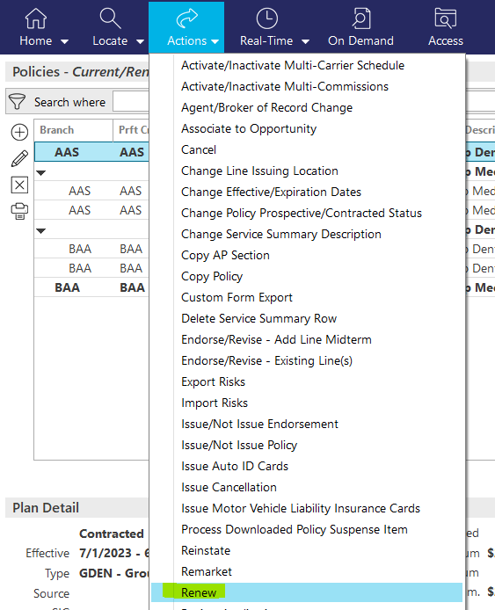

1. On the Renew Pop-Up Screen:
   1. Review the information on the renew screen and make sure all the information is correct based on the new renewal terms. Update any information that may need to be updated.

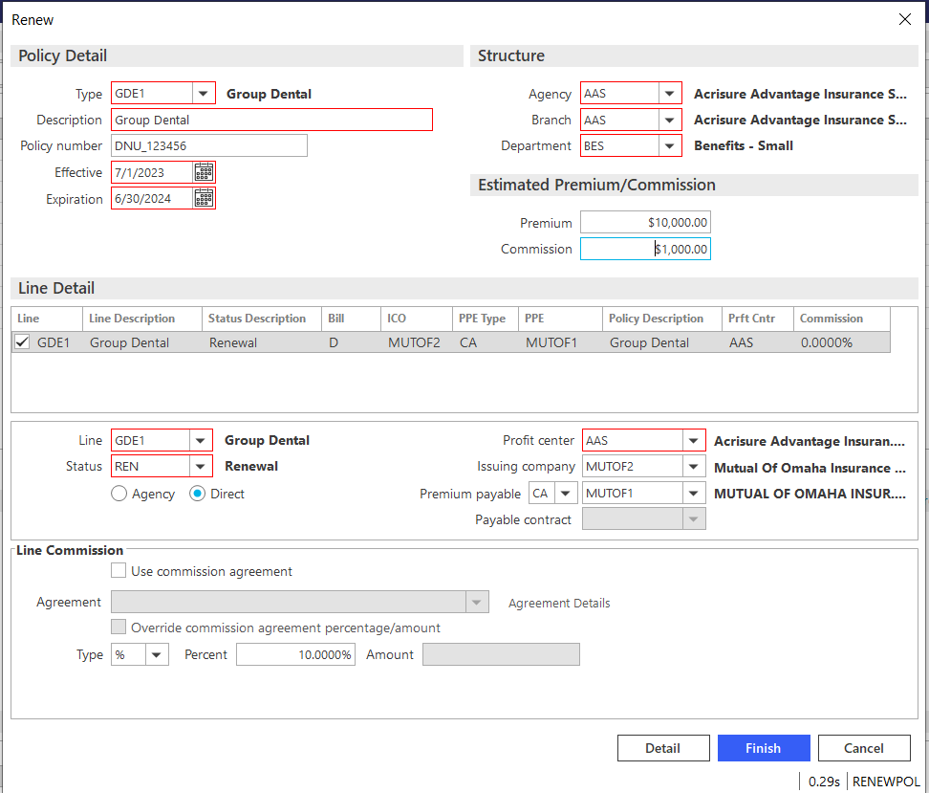

* 1. Click Detail.

1. 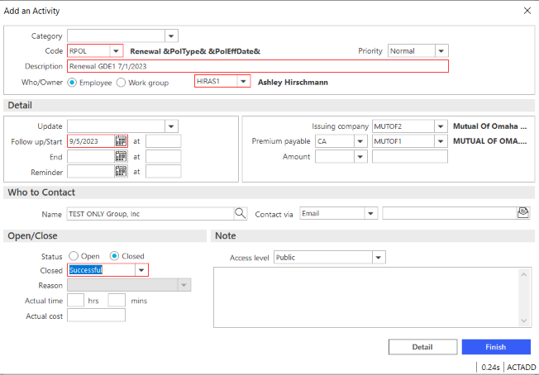Close the RPOL Activity as Successful.
2. On the left-hand side of the screen click “Line”
   1. Fill in the Premium and Commission amounts on the Line Tab
   2. Click on the PR/BR Commissions Tab and review the information to make sure all the information is correct. Update any information that may need to be updated.
3. Click on the X on the left to close out of the policy

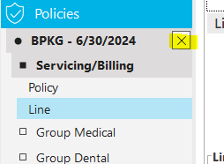

1. Select the Issue/Not Issue Policy option in the Yes, perform action drop down & click Finish

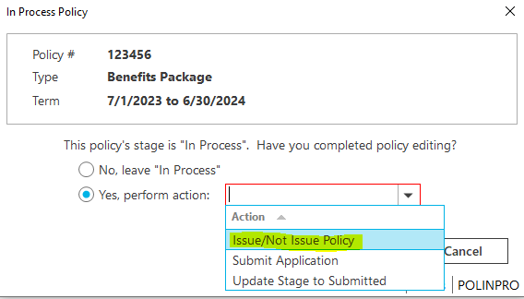

1. Click Finish on the pop-up issue confirmation screen